The Adventures of Jayda Rose

“Goodnight and ‘sweet adventures’ Jayda Rose,” whispered her mother. Jayda’s mother said ‘sweet adventures’ instead of sweet dreams for a very good reason. Jayda had an exceptionally curious and creative imagination, and Jayda’s mother knew she would have a story to tell in the morning.

Swiftly Jayda drifted off to sleep and awoke just as quickly …but, she was no longer in her comfy bed and definitely not in her room.

*Cough *Cough *Cough* *rubs eyes* …as the dust settles, Jayda sees a bustling city of …hmm, sand?!

“Lilly, where are we?” Jayda never went anywhere without her sidekick, Lilly. Jayda’s mother thought it was time to retire the old worn out stuffed puppy, but Jayda could not believe her best friend would ever get too old. Jayda’s best friend was as fearless as a tiger but a kitty at heart.

"Lilly, look at that", Jayda said enthusiastically pointing to the enormous hourglass in the horizon.

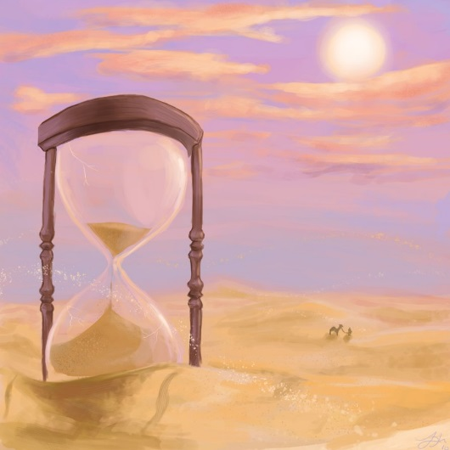

"We don't have much time, we have to figure out where...I mean when...huh!! Jayda wasn't sure where they were or even if they were in the same century. The people bustling around wore cloth robes and looked to be Egyptian. They were all working hard almost like an orchestrated village of ants building their home in the sand.

"Let's figure out who is in charge here, whoever it is must be very important." Lilly nodded in doggy agreement. Jayda and Lilly scanned the horizon with squinted eyes. "Over there!” Jayda pointed. There stood a gigantic structure, impossibly built by sand. "Let's go!" Jayda said with determination.

"Roo-oof??" Lilly gave a less than thrilled bark. Lilly knew there was no turning back, as she had been forced into many quests and some required wearing her famous dragon costume. While sometimes reluctant, she would not miss a minute with her Jayda Rose. "Ready to start our adventure Lilly?" "Ruff!"

They started their trek across the never ending sand. Jayda felt the hot sand beneath her feet that made walking strenuous, but determined as ever to reach her destination. She looked up at the bright blue sky and blinding sun, then stopped abruptly. There they were, at the foot of a giant sand castle. They entered through a giant cave-like doorway. It was remarkably cool inside, as well as stunning, the walls and tall ceilings were glowing in pure gold. "Lilly, this place must be made for giants… Royal king and queen giants!"

"Ooh look!" Their jaws dropped, on the wall behind the majestic throne was a beautiful portrait painting. They now knew who was in charge, "Cleopatra! The last Empress of Egypt!"
"Ruff-ruff-ruff-ruff" Lilly barked her best Cle-o-pa-tra.

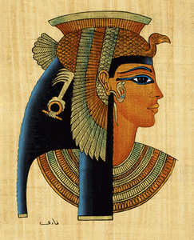

"Well, we know where we are now. Let's find her Lilly!" "Ruff!"

Jayda was reminded that her mother always quizzed her at breakfast time on what she learned the prior day, and thanks to Jayda’s adventures she always came prepared. "Let me hear 'em," her mother would say as soon as she sat down with her cereal. Which meant, give her enough facts to fill a hand full of fingers. Jayda and Lilly loved to make Mommy proud.

"Time to explore." Jayda said to Lilly. She slowly scanned the giant room, "Which way, Lilly?"
*Sniff* *Sniff* *Sniff* Lilly had a nose for adventure and loved to lead the way. “Whoa, not so fast Lilly!"

Lilly pulled Jayda Rose down a maze of corridors, "Stop, Lilly, stop! Where are we?" Finally Lilly came to an abrupt halt. She panted out of breath, then proudly looked up at Jayda. Jayda’s eyes were wide, "What have you found Lilly?!" Slowly they walked into a magically decorated room.

"Ooh, Lilly, let's play dress up!" Jayda said, eyes wide with excitement. Lilly had found a bin filled with royal clothes. Before Jayda finished speaking, Lilly jumped into the pile of Royal Clothes, and as she popped her head up, she was fully dressed.

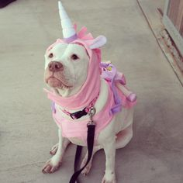

"I've always wanted to play dress up in royal Egyptian clothes." Jayda twirled around and remembered, "These are Cleopatra's clothes, Lilly. She became Empress at 18 years old. Do you remember now, Lilly? That was in 51 BC. Oh, and poor Cleopatra outlived 3 husbands by the age of 39, how sad Lilly." Jayda’s eyes welled up, and instantly she was dressed in full Egyptian garb.

Then "Uh,oh…do you hear that, Lilly?" They heard the marching of soldier’s feet.
"Shhhh, let’s hide!!" Lilly and Jayda pretended to blend in with the wall. As the sound faded, they peeked out to see the light of a torch traveling down the corridor, then the hallway finally became dark again.

"Lilly, come!" Jayda ushered Lilly into the hallway. "Let's follow them, but be very quiet." Lilly nodded worriedly. They followed the rhythmic sound of the marching feet through a maze of hallways. The two tip-toed slowly, not just to be cautious but to admire the Egyptian engravings covering the walls. They were in awe at the intricate artwork of the hieroglyphics.

"Look Lilly, isn't this amazing?" The two were awe struck, then...complete silence.

"Uh, Lilly I think we are lost, we have to find Cleopatra before time runs out!" "Ruff." Lilly barked in agreement. *Sniff* *Sniff* *Sniff* Lilly was on the scent for Cleopatra. Lilly handed her leash to Jayda and they took off.

"Whoa!" They dashed around in what Jayda thought was circles, then they screeched to a halt. Jayda looked up and was blinded by a brilliant light coming from the entryway. She could see a shadow coming towards them. Then she heard..."Welcome to Alexandria, Egypt. I am Empress Cleopatra and you are"...

"Jayda Rose… Jayda... Jayda Rose!" A familiar voice sounded from a distance, then slowly she came into focus. Jayda rubbed her eyes from the bright light, then she popped up, "Mommy?"

"Good Morning, Jayda, my dear, come down for breakfast. I can't wait to hear 'em." Her mother said, wiggling her fingers at Jayda Rose. Jayda smiled at her stuffed puppy and excitedly ran downstairs to the breakfast table with Lilly in stow!

Happy 5th Birthday to my sweet Jayda Rose!
Love, Mommy

